dClass: MATH 466 Numerical Methods

Professor: Eric Olsen

Team 1:

Michael Dorado

Maverick Marsala

Matthew Neill

Adrian Samberg

Date: 12/7/21

Assignment: Project 2

Problem 1:

1. This section used an input matrix A and an iteration defined as follows, respectively:

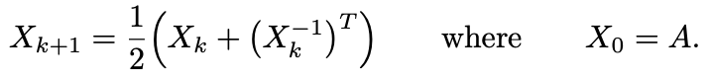

By making X0 equal to matrix and solving X1 for the first iteration, we can compute the Frobenius norm is 16.3705, confirming the matrix is correctly entered and the iteration is being calculated correctly.

**Code:**

**Output:**

1. In this section we perform ten iterations (zero through nine) of the matrix operation defined in part a. We then create the vector delta to track the Frobenius norms for each iteration as well. We can see that these Frobenius norms approach zero as iterate through the operation.

**Code:**

**Output:**

1. In this section we calculate plot, on a logarithmic scale, sequential delta values. This, if a line, shows that we have a quadratic order convergence. We verify this by computing alpha, which is the slope between the last two points on the graph. We see that alpha is 2, so we confirm quadratic convergence that we see in the plot.

**Code:**

**Output:**

1. This section confirms that W is orthogonal because $X^{T}$ $X$* converges towards the identity matrix.

**Code:**

**Output:**

1. In this section we found that some of the eigenvalues of A are negative and some of them are imaginary. In P we see that all the eigenvalues are positive and real.

**Code:**

**Output:**

